**BIOLOGY B**

**COURSE SYLLABUS**

**Instructor: Amie Stover**

**Phone: 506-6253**

**E-mail: amie.stover@anoka.k12.mn.us**

**Office Hours: After School or by appointment**

**COURSE DESCRIPTION:**

This course is designed to introduce the concepts of biology. Students will learn about living things, their life processes, their interactions, and their relationships. Through a variety of activities including lecture, discussion, group work, videos, and hands-on laboratory investigations, students will study ecology, cells, genetics, evolution, plants, and animals.

**MATERIALS:**

You will be prepared for class each day by bringing the following materials: 3 ring binder with lined paper (or notebook and folder to hold papers) and writing utensil (pencil preferred).

**GRADING:**

Grading will be weighted as follows:

Tests/Quizzes: 50% Homework/Labs: 40% Final Exam: 10%

Grade updates will be posted 2 days after each test, in the classroom and on AH Connect. Letter grades will be assigned as follows:

A=90-100% B=80-89% C=70-79% D=60-69% F=below 60%

# PARTICIPATION

Two participation points will be earned each day of class (being in class on time, prepared, involved in activities). Part of participating in class is being present to take part in our activities, so participation points will be deducted each time you use a pass to leave class. This does not apply to passes from the offices. Points for absences can be made up with current events article summaries.

**LATE ASSIGNMENTS:**

Assignments are given full credit if they are stamped at the **start** of class on the due date. Assignments only count as being on time if they are fully complete. Late assignments will earn ½ credit.

* If you are absent, you will have two days to make up an assignment for full credit.

**BEHAVIOR:**

Because our classroom contains many types of lab equipment, students must follow safety procedures at all times while in the room. You will be asked to report to the office if your actions pose a safety hazard for any other student in the room. You may also be removed from class if your actions are disruptive or distracting other students from their learning. Students caught cheating will receive a zero on that test or assignment.

**ACADEMIC INTERVENTIONS:**

Students are expected to organize their materials and time so that they can keep up with the pace of material and assignments in this class. I will be available before and after school, as well as by e-mail, if you have any questions about assignments or information that we learn in class. Individual plans will be created with all students who are not achieving to help them pass the class.

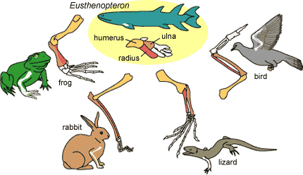

**COURSE OUTLINE:**

* Introduction to biology
* DNA
  + Structure
  + Replication
  + Code
  + Protein synthesis
* Genetics
  + Mitosis-Meiosis
  + Mendelian Genetics
  + Mutations

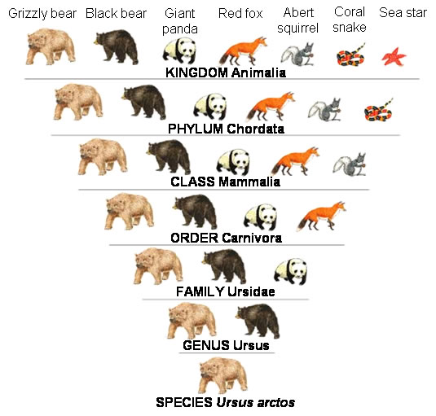

* Processes of Change (Evolution)
  + Evidence for Evolution
  + Natural selection
  + Selective pressures
* Diversity and animal body systems
  + Classification
  + Kingdoms
  + Animal phyla
  + Digestion
  + Circulation
  + Respiration
  + Nervous

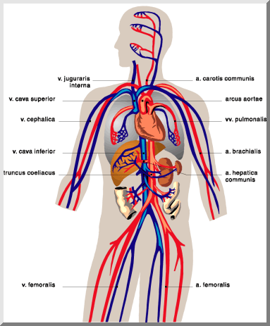

**STOVER’S**

**TIPS FOR SUCCESS:**

1. **BE ON TIME**
2. **COME PREPARED TO WORK**
3. **DO YOUR WORK**
4. **DON’T LOSE IT**
5. **TURN IT IN**